Mobile Application Development Lab

Course Outcome 1

Submitted By: Jomin K Mathew

20MCA321

GitHub Link: https://github.com/TKM-MCA-2020-MOBILE-DEV-LAB/20MCA221-JOMIN-K-MATHEW/tree/master/Course%20Outcome%201

1. Design a Login Form with username and password using LinearLayout and toast valid credentials

Activity_main.xml:

<?xml version="1.0" encoding="utf-8"?>

<LinearLayout xmlns:android="http://schemas.android.com/apk/res/android"

xmlns:app="http://schemas.android.com/apk/res-auto"

xmlns:tools="http://schemas.android.com/tools"

android:layout_width="match_parent"

android:layout_height="match_parent"

android:orientation="vertical"

tools:context=".MainActivity" >

<TextView

android:id="@+id/textView"

android:layout_width="match_parent"

android:layout_height="72dp"

android:fontFamily="@font/alfa_slab_one"

android:text="Login Page"

android:textColor="#733B3B"

android:textColorHighlight="#9F9494"

android:textColorHint="#59A677"

android:textColorLink="#5A4040"

android:textSize="34sp" />

<EditText

android:id="@+id/name"

android:layout_width="match_parent"

android:layout_height="124dp"

android:ems="10"

android:hint="Name"

android:inputType="textPersonName"

android:textSize="20sp" />

<EditText

android:id="@+id/password"

android:layout_width="match_parent"

android:layout_height="131dp"

android:ems="10"

android:hint="Password"

android:inputType="textPassword"

android:textSize="20sp" />

<Button

android:id="@+id/login"

android:layout_width="match_parent"

android:layout_height="wrap_content"

android:background="#2F7A6E"

android:backgroundTint="#651E1E"

android:checkable="false"

android:fontFamily="@font/alfa_slab_one"

android:foregroundTint="#8A2828"

android:text="Login"

android:textSize="16sp"

app:iconTint="#7E3131"

app:rippleColor="#9F2525" />

</LinearLayout>

MainActivity.java:

package com.example.login;

import androidx.appcompat.app.AppCompatActivity;

import android.os.Bundle;

import android.view.View;

import android.widget.Button;

import android.widget.EditText;

import android.widget.Toast;

public class MainActivity extends AppCompatActivity {

EditText t1,t2;

Button b1;

@Override

protected void onCreate(Bundle savedInstanceState) {

super.onCreate(savedInstanceState);

setContentView(R.layout.activity_main);

t1=(EditText)findViewById(R.id.name);

t2=(EditText)findViewById(R.id.password);

b1=(Button)findViewById((R.id.login));

}

public void onClick(View view){

String a =t1.getText().toString();

String b =t2.getText().toString();

if((a.equals("admin"))&&(b.equals("admin")))

{

Toast.makeText(this,"Succesfully Logined",Toast.LENGTH_LONG).show();

}

else{

Toast.makeText(this,"Check username & password",Toast.LENGTH_LONG).show();

}

}

}

Output:

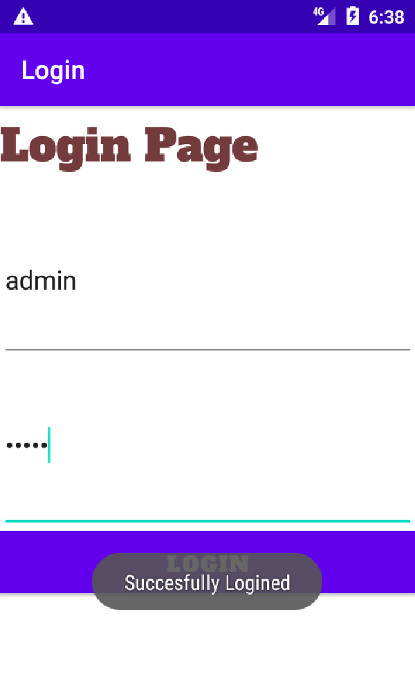

1. Write a program that demonstrates Activity Lifecycle.

Activity_main.xml:

<?xml version="1.0" encoding="utf-8"?>

<androidx.constraintlayout.widget.ConstraintLayout xmlns:android="http://schemas.android.com/apk/res/android"

xmlns:app="http://schemas.android.com/apk/res-auto"

xmlns:tools="http://schemas.android.com/tools"

android:layout_width="match_parent"

android:layout_height="match_parent"

tools:context=".MainActivity">

<TextView

android:layout_width="wrap_content"

android:layout_height="wrap_content"

android:text="Hello World!"

app:layout_constraintBottom_toBottomOf="parent"

app:layout_constraintLeft_toLeftOf="parent"

app:layout_constraintRight_toRightOf="parent"

app:layout_constraintTop_toTopOf="parent" />

</androidx.constraintlayout.widget.ConstraintLayout>

MainActivity.java:

package com.example.activitylifecycle;

import androidx.appcompat.app.AppCompatActivity;

import android.os.Bundle;

import android.util.Log;

public class MainActivity extends AppCompatActivity {

@Override

protected void onCreate(Bundle savedInstanceState) {

super.onCreate(savedInstanceState);

setContentView(R.layout.activity_main);

Log.i("State","onCreate");

}

@Override

protected void onStart() {

super.onStart();

Log.i("State","onStart");

}

@Override

protected void onResume() {

super.onResume();

Log.i("State","onResume");

}

@Override

protected void onPause() {

super.onPause();

Log.i("State","onCreate");

}

@Override

protected void onRestart() {

super.onRestart();

Log.i("State","onRestart");

}

@Override

protected void onStop() {

super.onStop();

Log.i("State","onStop");

}

@Override

protected void onDestroy() {

super.onDestroy();

Log.i("State","onDestroy");

}

}

Output:

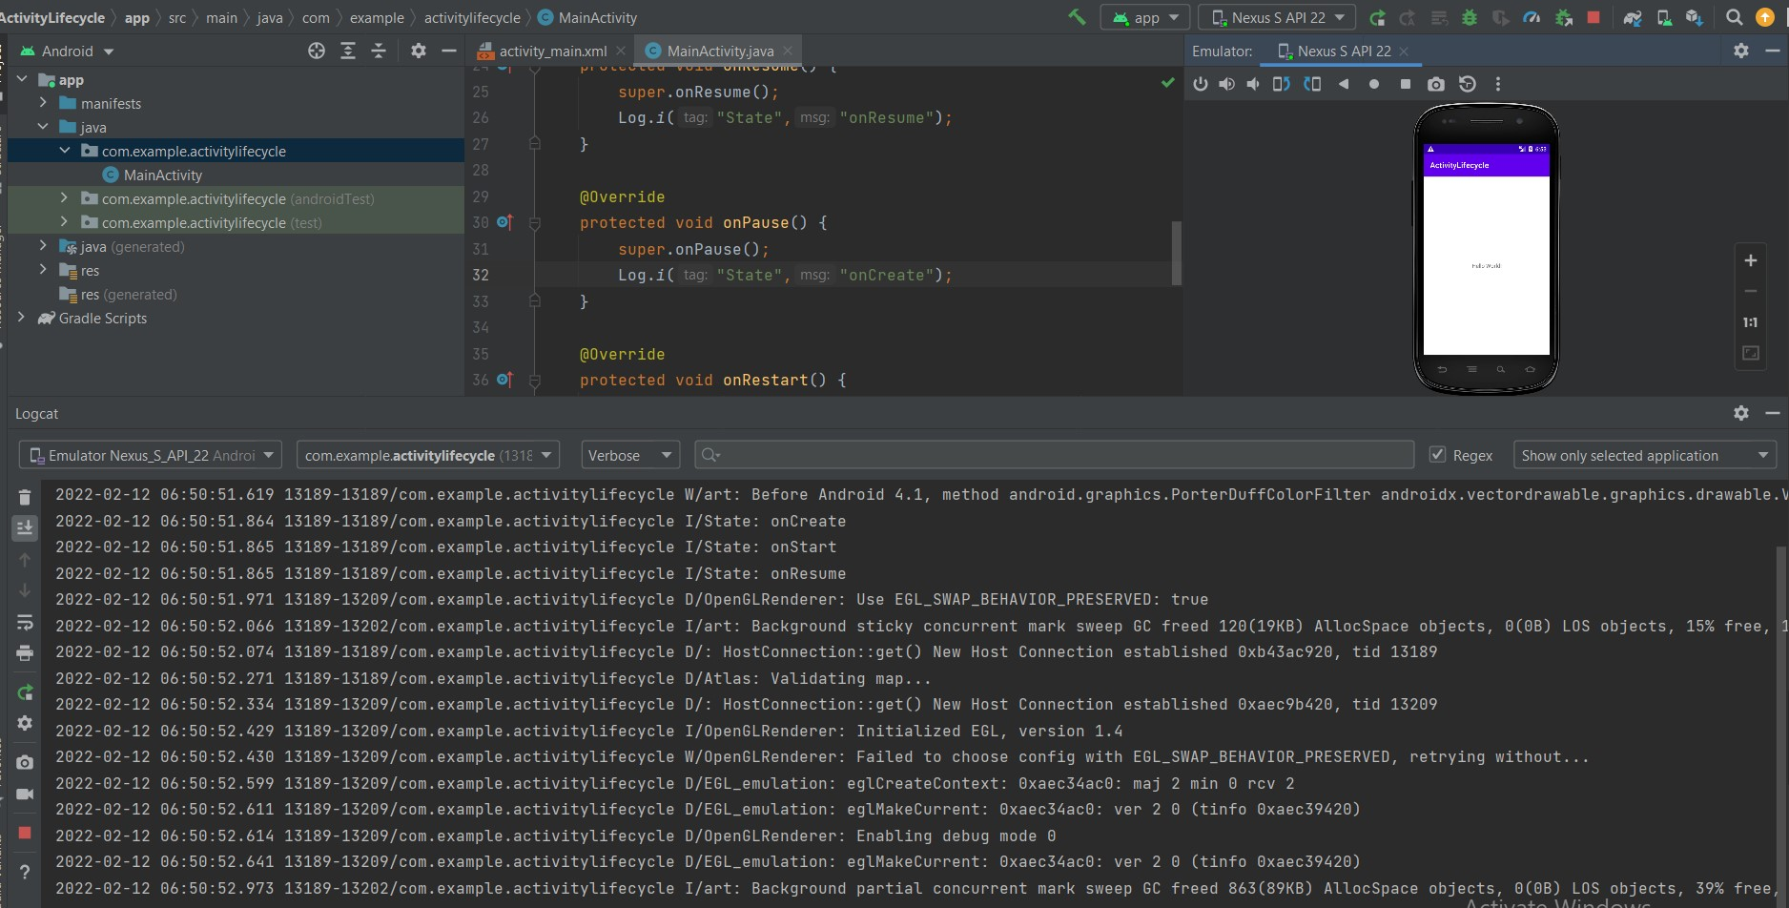

1. Implementing basic arithmetic operations of a simple calculator

Activity_main.xml:

<?xml version="1.0" encoding="utf-8"?>

<LinearLayout xmlns:android="http://schemas.android.com/apk/res/android"

xmlns:app="http://schemas.android.com/apk/res-auto"

xmlns:tools="http://schemas.android.com/tools"

android:layout_width="match_parent"

android:layout_height="match_parent"

android:orientation="vertical"

tools:context=".MainActivity">

<TextView

android:id="@+id/textView4"

android:layout_width="match_parent"

android:layout_height="53dp"

android:fontFamily="@font/archivo_black"

android:text="Simple Calculator"

android:textColor="#407B95"

android:textSize="20sp" />

<EditText

android:id="@+id/num1"

android:layout_width="match_parent"

android:layout_height="wrap_content"

android:ems="10"

android:hint="Enter the 1st number"

android:inputType="number" />

<EditText

android:id="@+id/num2"

android:layout_width="match_parent"

android:layout_height="wrap_content"

android:ems="10"

android:hint="Enter the 2nd number"

android:inputType="number" />

<EditText

android:id="@+id/result"

android:layout_width="match_parent"

android:layout_height="wrap_content"

android:ems="10"

android:hint="Result"

android:inputType="number" />

<Button

android:id="@+id/add"

android:layout_width="match_parent"

android:layout_height="wrap_content"

android:onClick="add"

android:text="ADD" />

<Button

android:id="@+id/sub"

android:layout_width="match_parent"

android:layout_height="wrap_content"

android:onClick="sub"

android:text="SUB" />

<Button

android:id="@+id/mult"

android:layout_width="match_parent"

android:layout_height="wrap_content"

android:onClick="mult"

android:text="Mult" />

<Button

android:id="@+id/div"

android:layout_width="match_parent"

android:layout_height="wrap_content"

android:onClick="div"

android:text="Div" />

</LinearLayout>

MainActivity.java:

package com.example.calculator;

import androidx.appcompat.app.AppCompatActivity;

import android.os.Bundle;

import android.view.View;

import android.widget.EditText;

import android.widget.Button;

public class MainActivity extends AppCompatActivity {

EditText e1,e2,e3;

Button b1,b2,b3,b4;

@Override

protected void onCreate(Bundle savedInstanceState) {

super.onCreate(savedInstanceState);

setContentView(R.layout.activity_main);

e1=(EditText)findViewById(R.id.num1);

e2=(EditText)findViewById(R.id.num2);

e3=(EditText)findViewById(R.id.result);

b1=(Button)findViewById(R.id.add);

b2=(Button)findViewById(R.id.sub);

b3=(Button)findViewById(R.id.mult);

b4=(Button)findViewById(R.id.div);

}

public void add(View view)

{

int a=Integer.parseInt(e1.getText().toString());

int b=Integer.parseInt(e2.getText().toString());

String c=String.valueOf(a+b);

e3.setText(c);

}

public void sub(View view)

{

int a=Integer.parseInt(e1.getText().toString());

int b=Integer.parseInt(e2.getText().toString());

String c=String.valueOf(a-b);

e3.setText(c);

}

public void mult(View view)

{

int a=Integer.parseInt(e1.getText().toString());

int b=Integer.parseInt(e2.getText().toString());

String c=String.valueOf(a*b);

e3.setText(c);

}

public void div(View view)

{

float a=Integer.parseInt(e1.getText().toString());

float b=Integer.parseInt(e2.getText().toString());

String c=String.valueOf(a/b);

e3.setText(c);

}

}

Output:

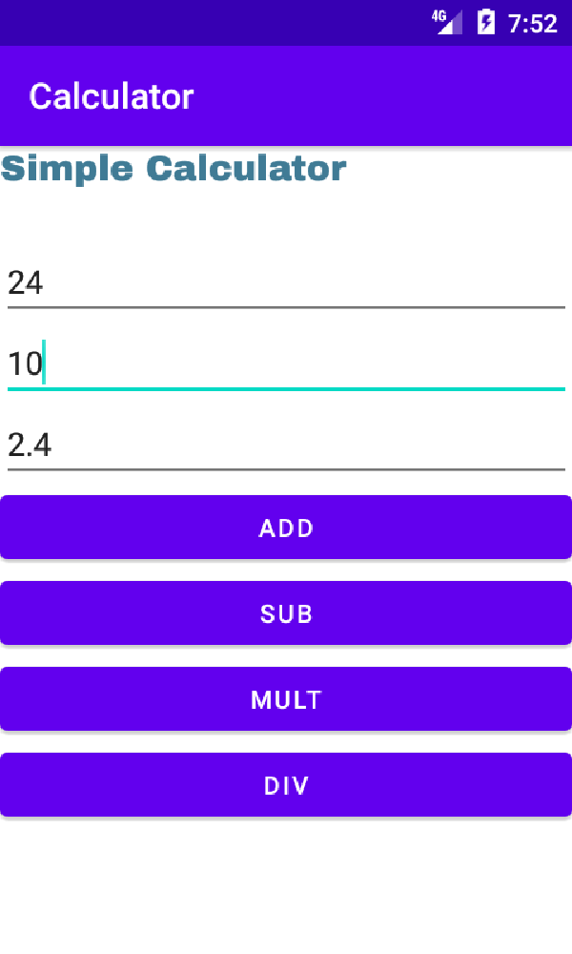

1. Implement validations on various UI controls

Activity_main.xml:

<?xml version="1.0" encoding="utf-8"?>

<LinearLayout xmlns:android="http://schemas.android.com/apk/res/android"

xmlns:app="http://schemas.android.com/apk/res-auto"

xmlns:tools="http://schemas.android.com/tools"

android:layout_width="match_parent"

android:layout_height="match_parent"

android:baselineAligned="false"

android:orientation="vertical"

android:textAlignment="center"

tools:context=".MainActivity">

<TextView

android:id="@+id/textView3"

android:layout_width="match_parent"

android:layout_height="48dp"

android:fontFamily="@font/baloo_chettan"

android:text="Validation Form"

android:textColor="#3D2361"

android:textSize="24sp" />

<EditText

android:id="@+id/name"

android:layout_width="match_parent"

android:layout_height="wrap_content"

android:ems="10"

android:hint="Enter the Name"

android:inputType="textPersonName" />

<EditText

android:id="@+id/email"

android:layout_width="match_parent"

android:layout_height="60dp"

android:ems="10"

android:hint="Enter the Email"

android:inputType="textEmailAddress" />

<EditText

android:id="@+id/number"

android:layout_width="match_parent"

android:layout_height="wrap_content"

android:ems="10"

android:hint="Enter Phone number"

android:inputType="phone" />

<EditText

android:id="@+id/address"

android:layout_width="match_parent"

android:layout_height="wrap_content"

android:ems="10"

android:hint="Enter the Address"

android:inputType="textPersonName" />

<EditText

android:id="@+id/password"

android:layout_width="match_parent"

android:layout_height="wrap_content"

android:ems="10"

android:hint="Enter the password"

android:inputType="textPassword" />

<Button

android:id="@+id/button"

android:layout_width="match_parent"

android:layout_height="wrap_content"

android:onClick="onSubmit"

android:text="Submit" />

</LinearLayout>

MainActivity.java:

package com.example.registration;

import androidx.appcompat.app.AppCompatActivity;

import android.os.Bundle;

import android.view.View;

import android.widget.EditText;

import android.widget.Toast;

public class MainActivity extends AppCompatActivity {

@Override

protected void onCreate(Bundle savedInstanceState) {

super.onCreate(savedInstanceState);

setContentView(R.layout.activity_main);

}

public Boolean validateName(){

EditText ed1 = (EditText) findViewById(R.id.name);

String name = ed1.getText().toString();

if (name.isEmpty()){

ed1.setError("Name cannot be empty");

return false;

}

else {

return true;

}

}

public Boolean validateAddress(){

EditText ed5 = (EditText) findViewById(R.id.address);

String address = ed5.getText().toString();

if (address.isEmpty()){

ed5.setError("Address cannot be empty");

return false;

}

else {

return true;

}

}

public Boolean validateEmail(){

EditText ed2 = (EditText) findViewById(R.id.email);

String email = ed2.getText().toString();

String emailPattern = "[a-zA-Z0-9._-]+@[a-z]+\\.+[a-z]+";

if (email.isEmpty()){

ed2.setError("Email cannot be empty");

return false;

}

else if (!email.matches(emailPattern)){

ed2.setError("Invalid email address");

return false;

}

else{

return true;

}

}

public Boolean validateNumber() {

EditText ed3 = (EditText) findViewById(R.id.number);

String num = ed3.getText().toString();

String numval = ".{10,}";

if (num.isEmpty()) {

ed3.setError("Phone number cannot be empty");

return false;

} else if (!num.matches(numval)) {

ed3.setError("Check it exist 10 numbers");

return false;

} else {

return true;

}

}

public Boolean validatePassword(){

EditText ed4 = (EditText) findViewById(R.id.password);

String pswd = ed4.getText().toString();

String passwordVal = "^" +

//"(?=.*[0-9])" + //at least 1 digit

//"(?=.*[a-z])" + //at least 1 lower case letter

//"(?=.*[A-Z])" + //at least 1 upper case letter

"(?=.*[a-zA-Z])" + //any letter

"(?=.*[@#$%^&+=])" + //at least 1 special character

"(?=\\S+$)" + //no white spaces

".{4,}" + //at least 4 characters

"$";

if (pswd.isEmpty()){

ed4.setError("Password cannot be empty");

return false;

}

else if (!pswd.matches(passwordVal)) {

ed4.setError("Password is too weak");

return false;

}

else{

return true;

}

}

public void onSubmit(View view){

if(validateName() && validateEmail() && validateNumber() && validateAddress() && validatePassword()){

Toast t = Toast.makeText(getApplicationContext(),"Succesfully Submitted",Toast.LENGTH_LONG);

t.show();

}

}

}

Output:

